

Scoreboard Reading 101
Reading our scoreboard takes a bit of getting used to. Olympic level curling on television has the advantage of computerized digital scoreboards. Most curling clubs rely on the hang tag method, it's simple, it needs only one set of numbers representing the ends played, and it works. No computer glitches here.
Before we start the game, the scoreboard is obviously blank. The blue numbers across the middle, 1 through 14 represent the potential points. More than 14 is possible, but incredibly rare, so to conserve space and improve legibility from the far end of the sheet most curling clubs utilize large numbers and letters and quit at 14 or 15.
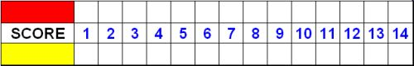
First end - Yellow scores two points. Red gets none because only one team can score in any end. The hang tag is placed in the yellow row (because they scored the points) under the number 2 (blue row of points in the center). The score is Red - 0, Yellow - 2. The #1 on the hang tag indicates this was the first end.
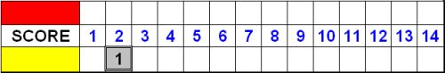
Second end - Red scores three, a great end for them. The hang tag goes in the red row, over the number 3. The score is Red - 3, Yellow - 2. The #2 on the hang tag indicates the second end
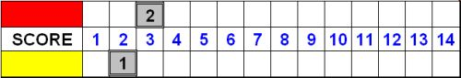
Third end - Yellow scores one. Yellow already has two points from the first end, and took one more in the third end for a total of three. The hang tag goes in the yellow row under their current score of three. It's now a tie game, Red - 3, Yellow - 3.
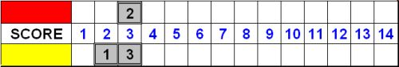

Continued on the reverse side

Fourth end - Nobody scores! It's called a "blank end". No rocks were in the house. Red keeps the all important hammer (the last rock to be thrown in the end) because yellow scored the last point(s), and the hang tag is placed somewhere out of the way. We place the hang tag sideways under the word "score", although many clubs hang it all the way at the far right end under the #14. It clearly doesn't count for points.
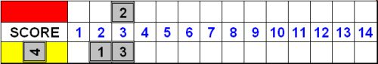
Fifth end - Yellow steals two. It is called stealing a point when the other team has hammer. Yellow already has three, stole two more for a new total of five. The hang tag goes under the 5. The score is now Red - 3, Yellow - 5.
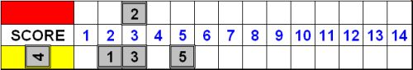
Sixth end - Yellow steals two more. Yellow already has five, stole two more for a new total of seven. The hang tag goes under the 7. The score is now Red - 3, Yellow - 7. Red, being the good sports that they are, recognize the inevitable and shake hands. Broomstacking commences.
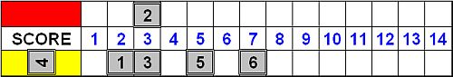
The Hammer – is the last rock thrown in an end. It is the last opportunity to score additional points, to reduce your opponent’s points, or even to score when things are looking grim. The hammer changes from end to end so that one team does not always have the all important hammer. If you score in an end, then you throw first, giving the opposition the hammer, or last rock advantage. The hammer in the first end is frequently the result of a coin toss.
Summary - The total points scored are across the middle. The hang tags and placement represent the ends in which points were scored and how many points. Which ever team scored most recently throws first in the next end - the other team has the hammer. The score after six ends is Red - 3, Yellow - 7.
In most league curling we only play for eight ends. In competition it's ten ends. An extra end is played to break a tie. Our example stops after six ends.

