Regular stone positioning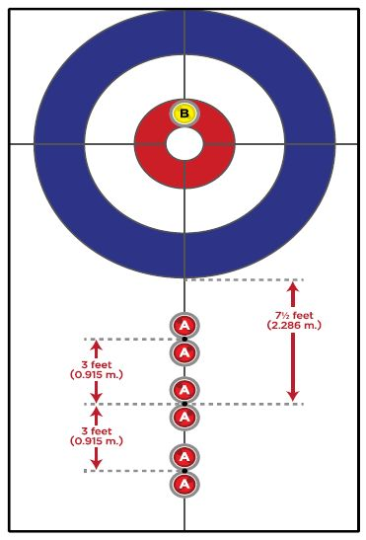 | Power play stone positioning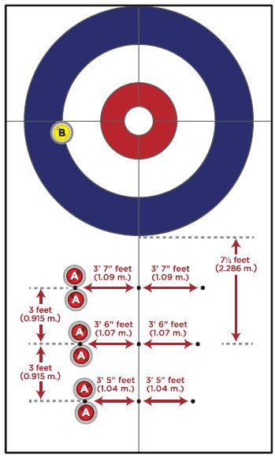
The team with stone “B” in the house has the hammer.

Throwing Stones: Five stones per team are thrown. One stone per team is positioned before the start of the end, and two are not used. Whoever throws the first stone on a team also throws the last. The second player on the team throws stones 2, 3, and 4. The player throwing first can change from end to end.

Modified Free Guard Rules: No stone in play, including stones in the house, may be removed prior to the 4th stone being thrown. The 4th delivered stone is the first stone that can remove another stone from play. The thrown stone may leave play.

Sweeping: The non-delivering player may be anywhere on the ice surface. Either or both players may sweep their own stones in motion anywhere in front of the tee line. The rules are strangely quiet about sweeping past the tee line. The interpretation is that anybody can sweep any stone past the tee line, but only one person per team at a time.

Hammer rules: If you did not score in the end (or won the coin toss / LSD) you have “the decision” on stone placement, and you may keep or give up the hammer.
- In the case of a blank end, whichever team threw first in the previous end has the decision. If the end is blanked due to a measure, the team with the decision will not change.
- You may place either color stone in the house – meaning the team with the stone in the house has the hammer, and the team with the stone positioned in front of the house throws first.
- You may choose the “power play” option once per game, either side, but not in extra ends. There could be two “power plays” in a game, one per team.

Ver. 3.2, 1/17/2025 -- hgg

